**PORTFOLIO**

**COMPUTER SCIENCE AND ENGINEERING**

Submitted by:

Name: Vansh Chopra

Registration number: 12406635

Roll No.: RK24CTB71

Section: K24CT

**Submitted to : Dr.**



**LOVELY PROFESSIONAL UNIVERSITY**

**DECLARATION**

I, Vansh Chopra, a student of Bachelor of Technology under CSE discipline at Lovely Professional University, Punjab, hereby declare that all the information furnished in this project report is based on my own work and is genuine

VANSH CHOPRA

Registrartion Number: 12406635

|  |  |  |
| --- | --- | --- |
| Platforms for profile creation | Link to student profile | Screenshot |
| ***Figma*** | Since internal profile doesn’t work, so I am attaching project link  Project1:  <https://www.figma.com/design/o5egYAKUXxe54X238UCONC/P>  ROJECT-1?t=CrdTjDEloZABegAS-0 | 1 |
| ***Quora*** | <https://www.quora.com/profile/Vansh-Chopra-89> | 2 |
| ***Stack overflow*** | <https://stackoverflow.com/users/23040153/yatish-kumar> | 3 |
| ***Hacker Rank*** | <https://www.hackerrank.com/profile/0310_simta> | 4 |
| ***Hacker Earth*** | <https://www.hackerearth.com/@0310.simta> | 5-6 |
| ***Geeks for Geeks*** | <https://www.geeksforgeeks.org/user/0310s7mlf/> | 7 |
| ***LinkedIn*** | <https://www.linkedin.com/in/vansh-chopra-386b5630a/> |  |
| ***Github*** | <https://github.com/Vansh1412> | 8 |
| ***Git*** |  | 9 |
| ***CV*** | <https://drive.google.com/file/d/1Y4_EVUAPxkTECUCaYjgc0lJi3btNBd_U/view?usp=drive_link> | 10 |
| ***MOOCS done*** | 1. LINUX COMMANDS AND SHELL SCRIPTING | 11 |
| ***Technical MOOC Registration*** | Registration link here.  PIC DOWN THERE |  |

1.FIGMA

Profile:

Figma internal profile with project

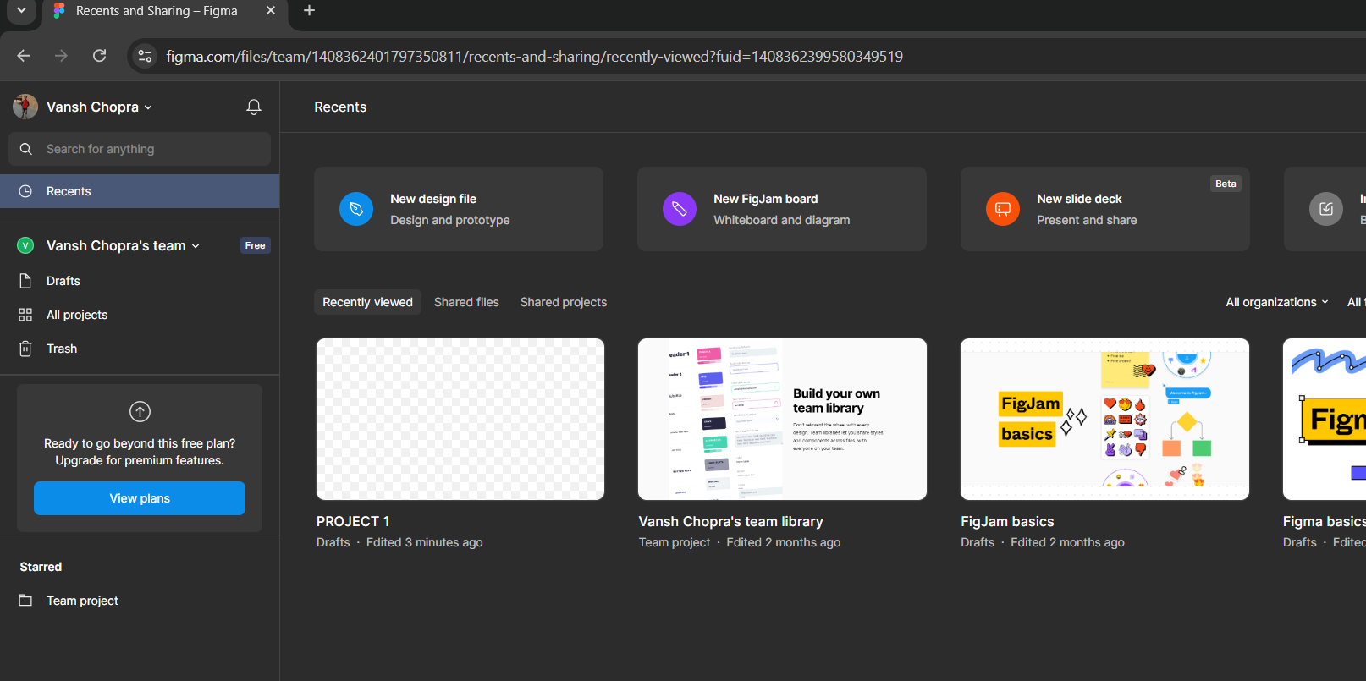

Accomplishment:

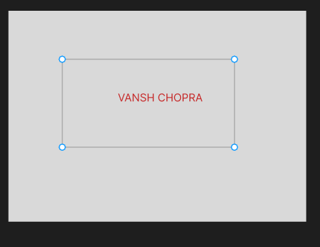

2.QUORA

PROFILE AND ACCOMPLISHMENT:

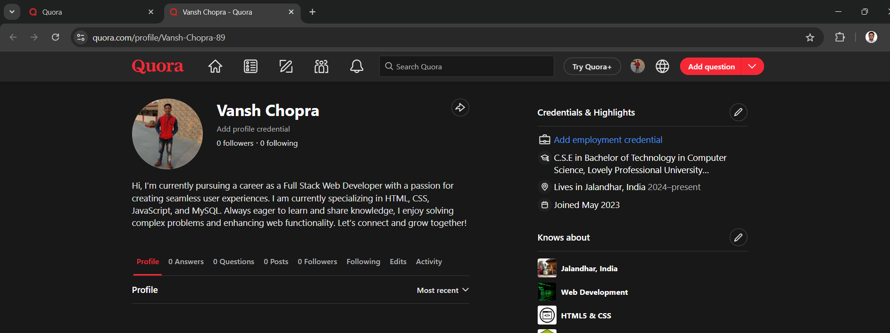

3.STACKOVERFLOW

PROFILE:

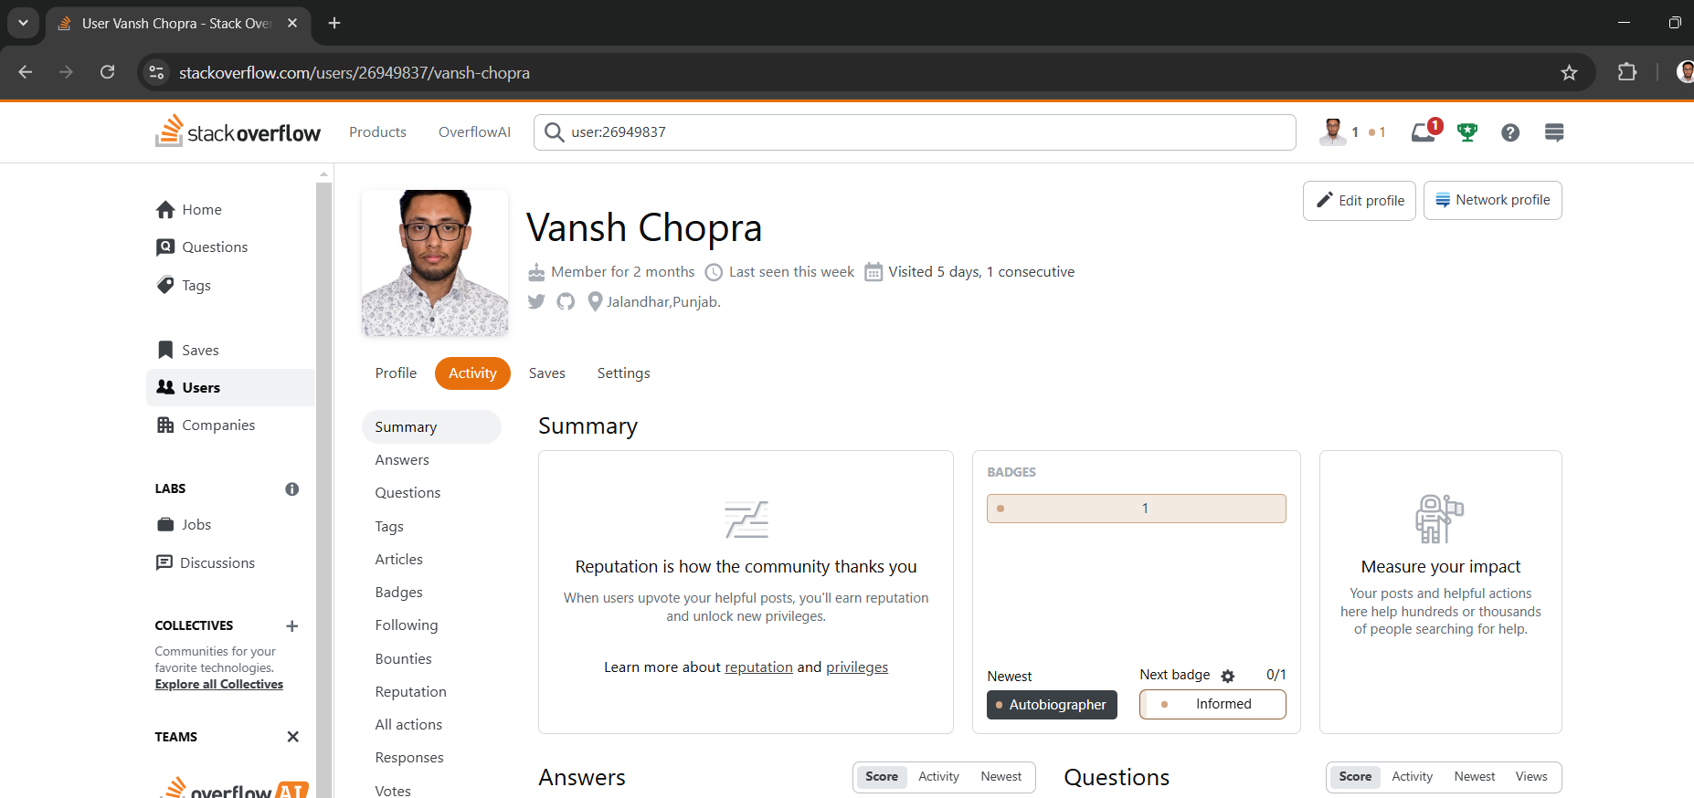

**4.HACKER RANK**

**Profile:** 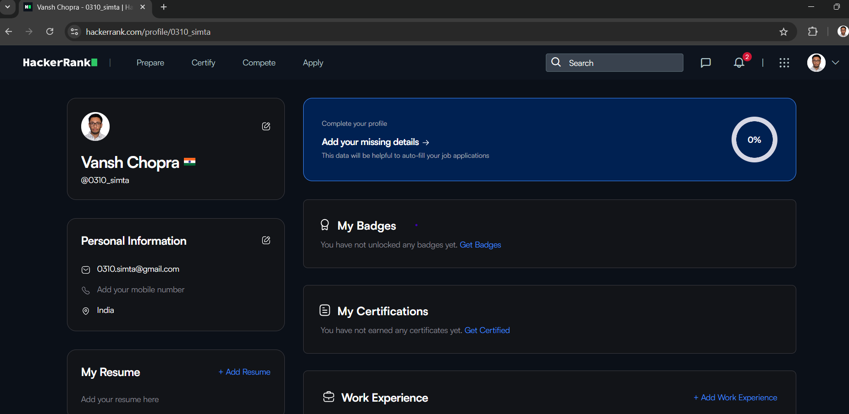

**5.HACKER EARTH**

**Profile:**

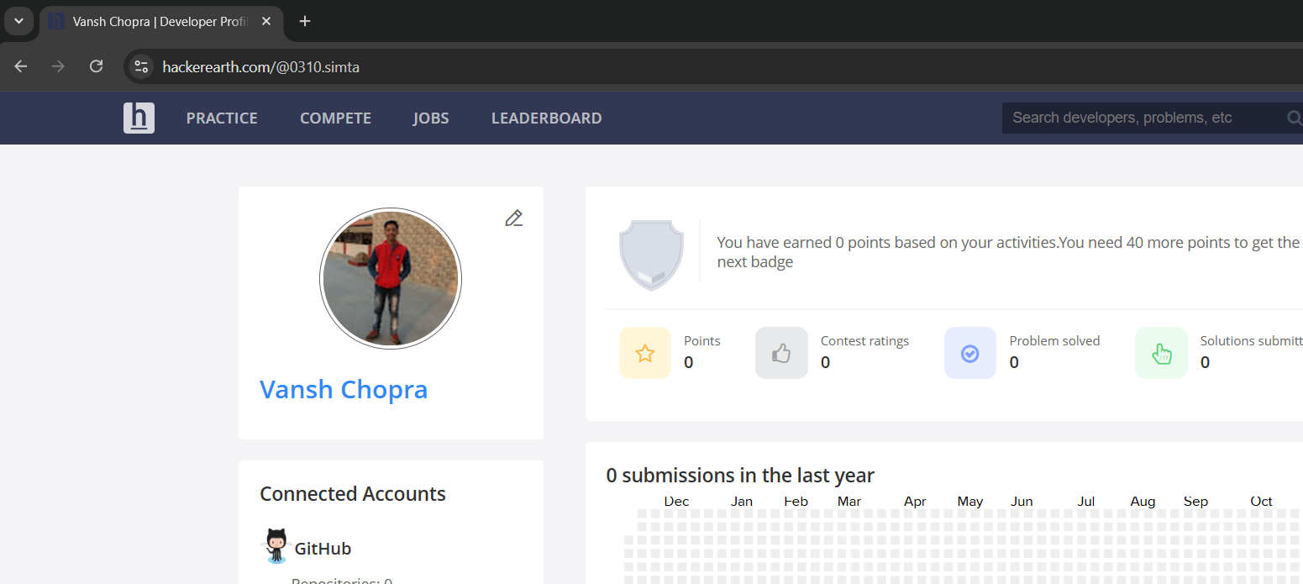

**6.GEEKS FOR GEEKS**

**Profile:**

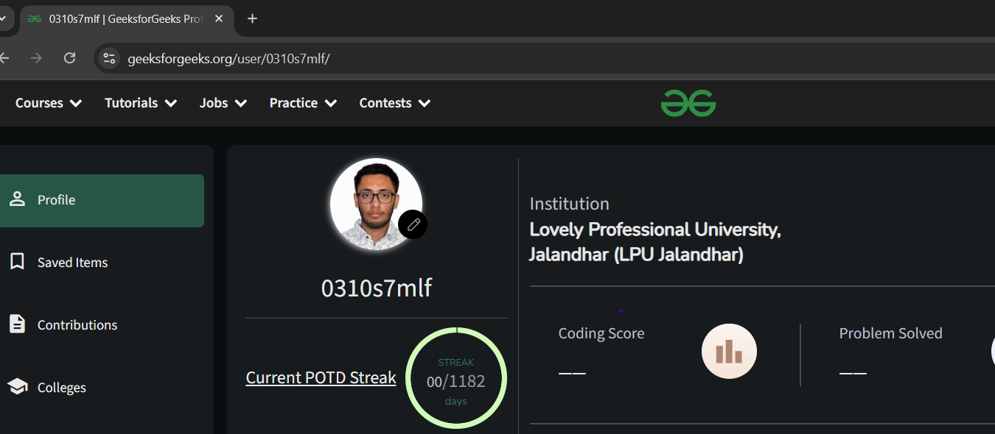

**8. GITHUB**

**Profile:**

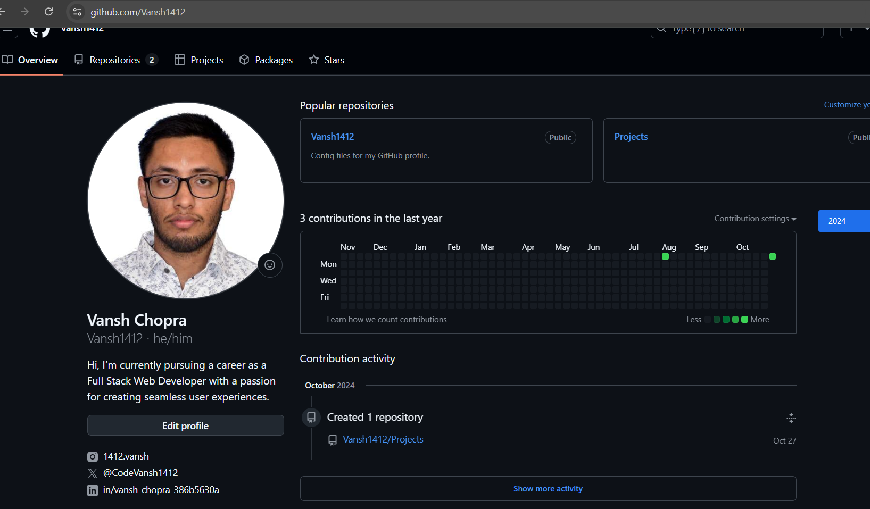

**10.CV**

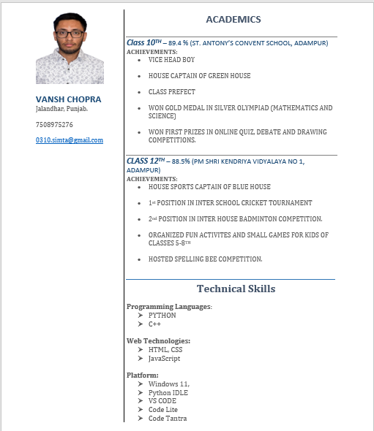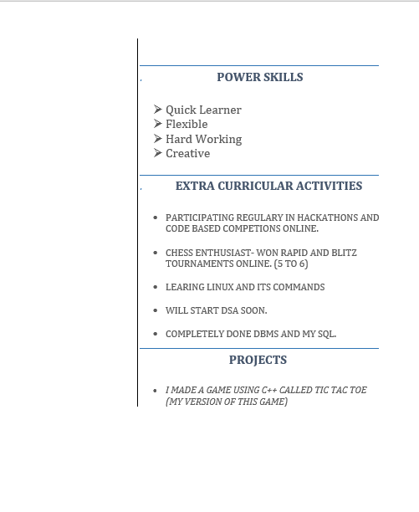

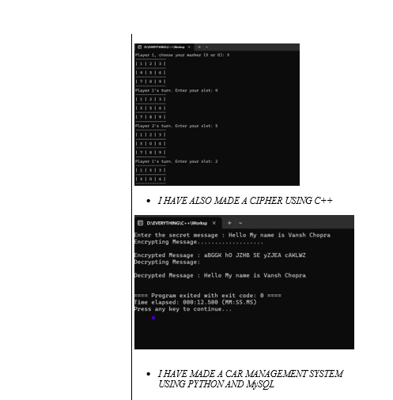

**11.MOOCS completed**

**11.Technical MOOC registration Link**

